Name ___________________________ Homework Oct.3-7

Put your initials by each night that your child practiced the following:
_____Monday _______ Tuesday ____Thursday
*Nightly Homework*
1. Count numbers 1-25.
2. Say the following letter names and sounds:

Mm Ss Tt Bb Aa Nn Dd

Practice writing your first name with only the first letter upper case.

Practice writing letters Nn and Dd.

N________________________________

n___________________________

D___________________________

d___________________________

Write the beginning sounds for these words:

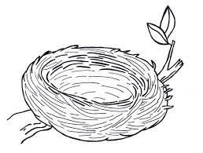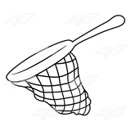

__ og __ est __et __oll

Say the word, count the syllables, and circle the number you hear.

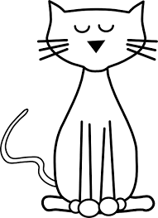  1 2 3 4 | 1 2 3 4 | 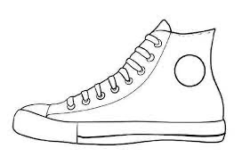  1 2 3 4
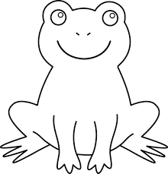  1 2 3 4 | 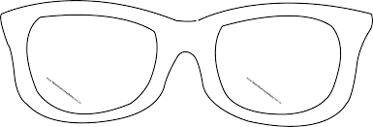  1 2 3 4 | 1 2 3 4

Week Oct. 3-7
(Please let your child read this to you)

Words to know:

is man no
Go, Tad
“Tad, see the ball? Go to the ball!”
“A nest? No, Tad. Go to the ball!”
“A doll? No, Tad! Go to the ball!”
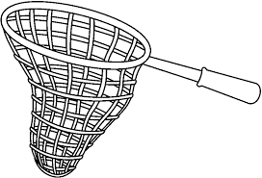
“A net? No, Tad!”
“See the man, Tad? The ball is by the man.”

“Tad!”

